Game Design Document

David Whiteford

Paul O’ Callaghan

Alan Bolger

**Mission Statement** **3**

**Genre** **3**

**Platforms** **3**

**Target Audience** **3**

**StoryLine** **3**

**Characters** **3**

**Gameplay** **4**

[Overview of Gameplay](https://docs.google.com/document/d/1zmpcerHhFAwFpI1CB6OZxwyfEkOkMqWZ12qmfWB8wA8/edit#heading=h.4d34og8) [4](https://docs.google.com/document/d/1zmpcerHhFAwFpI1CB6OZxwyfEkOkMqWZ12qmfWB8wA8/edit#heading=h.4d34og8)

Gameplay Guidelines 4

Gameplay Mechanics 6

Level Design 6

**Control Scheme** **6**

**3D and Assets** **7**

**User Interface** **7**

[**Task Schedule**](https://docs.google.com/document/d/1KY4AKOAbUAaG6EHr0XkUA-0s1aOhW7AhKUR6bqy9Rn4/edit#heading=h.nd154hj3m3z3)[**7**](https://docs.google.com/document/d/1KY4AKOAbUAaG6EHr0XkUA-0s1aOhW7AhKUR6bqy9Rn4/edit#heading=h.nd154hj3m3z3)

**Testing** **8**

# 

# 

# **Mission Statement**

To make a fun and engaging game that will show off our technical abilities and push ourselves to exceed our own expectations.

# **Genre**

Action / Maze / First Person Shooter / Arcade

# **Platforms**

The game will be available on PC.

# **Target Audience**

The target audience will be made up of demographics for 13 years and older. For those who enjoy Pac-Man but with an edgier tone.

# **StoryLine**

You are a piece of tofu. You were genetically engineered by the demons of hell themselves to enslave humanity. The demons did not expect one thing though. This piece of tofu has the heart of an angel with the capacity for vengeance of a demon. Now the demons are trying to stop you from escaping and it’s up to you Tofu, to show them a hell of their own. Use your arsenal of weapons to destroy the demons and take as many down with you as possible before they send you back into oblivion.

# **Characters**

Tofu - They were created by the demons of hell. Now they seek vengeance for bringing them into this world of torture. Not much is known about tofu or why they have decided to turn on their creators but the good thing is they side with the humans at least.

Demon - These were the researchers of hell that created tofu. They wish to enslvae humanity and feast on their souls eternally. They have many roles in their society akin the the way humans live but much more like a colony of ants as they live to serve their queen Satan.

Satan - She is the queen bee if hell. She only comes out when her worker demons can’t contain the trouble though she enjoys a little ruckus now and then it keeps the eternal passage of time exciting. While her physical form can be destroyed her physical form can always come back no matter what so don’t be surprised if she pops up again and again and again.

# 

# **Gameplay**

# **Appearance**

The graphics will be in 3D while operating on a 2D plane unbeknownst to the player. Visual similarities would be wolfenstein, doom and the windows 3D screensaver that goes through a 3d maze. The User Interface (UI) will appear on the bottom of the screen as to not obscure the players vision of the game world at any time. This will display health, bullets and score

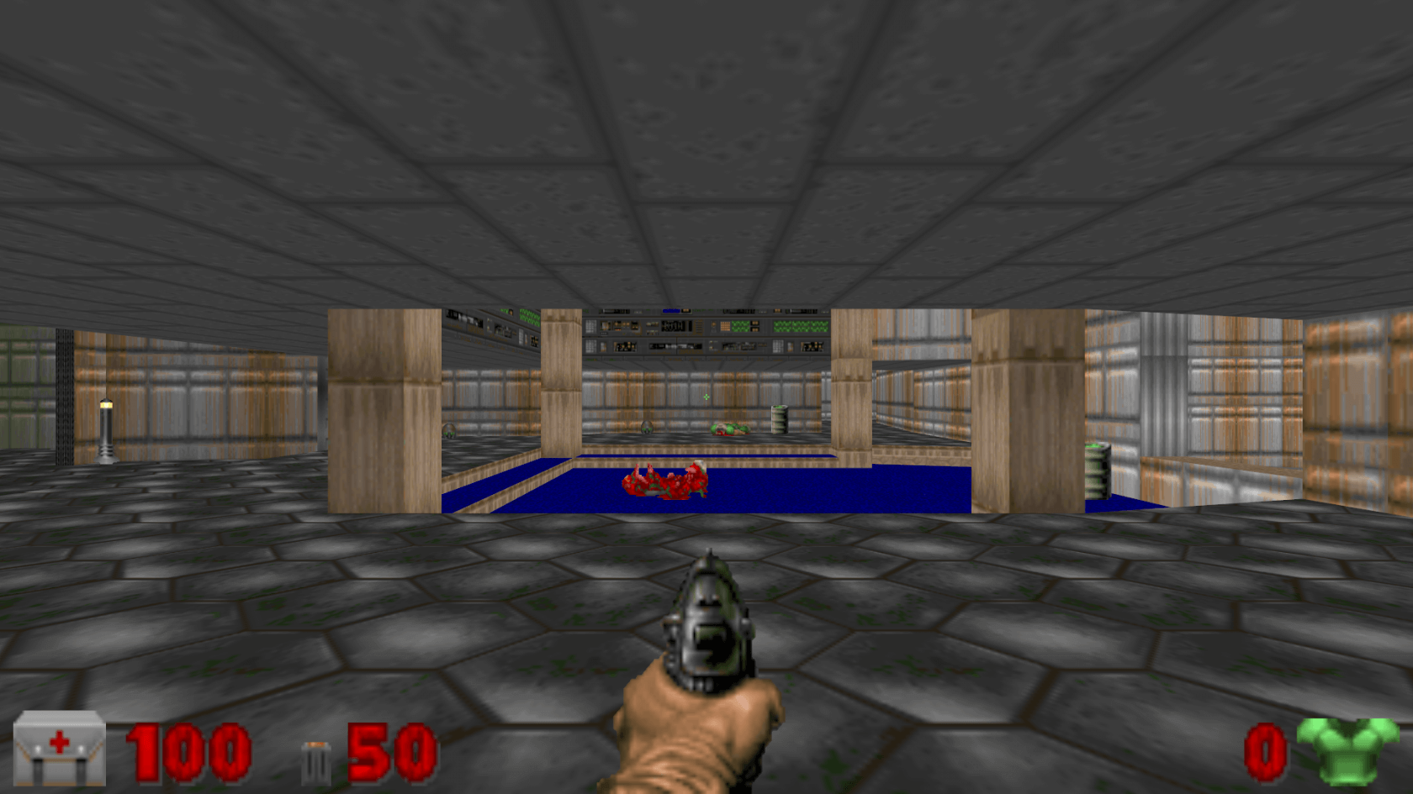

# **Overview of Gameplay**

The main goal of the game is for the player to get to the end of the maze and take out the demon queen Satan. The maps will be procedurally generated being maximum size of 5x5 rooms, where on start and destruction of the queen will generate a new map for the player to continue their killing spree with enemies becoming tougher and faster. The game ends when the player dies or decides to quit the game from the pause menu which will take them to the main menu. From the main menu they can start another game, change settings or close the application.

## **Gameplay Guidelines**

On loading up the game is brought to the main menu. From here they can adjust settings, start the game and quit the game. At the menu settings they can adjust volume of the background music and sound effects. Upon selecting starting the game the level loads a seed for generating a level layout and then places the player in a room. From here they can run shoot and kill enemies as well as find items and weapons to aid in their conquest to defeat the demons.

|  |  |
| --- | --- |
| Object / Type | Description |
| Health Pack | The player will collect a health pack by running into it. This will add health to the players current health not exceeding the max health values. |
| Score UI | This will display the current score that the player has attained so far. |
| Ammo Pack | This will replenish all or some of the players existing ammunition. Ammunition is used to fire off their gun and damage enemies |
| Orb of Death | This is an orb that enemies use as projectiles to damage and hurt the player. They come in many forms mostly in the killing form. |
| Machine Gun | This is a weapon pick up that allows the player to shoot automatic rounds. It damages the enemy a little less than a handgun but hits them more times faster making up for the lack of power. |
| Shotgun | This is a weapon pick up that allows the player to shoot many rounds of bullets in a spread range of +/-30 degrees. It is best used at close range. Up close it is a power house, at a distance and the accuracy is a little undependable for this one. |
| Hand Gun | This weapon is automatically part of the player arsenal. It shoots single rounds and does 1 unit of damage. |
| Demon | These are the drones of the queen of evil. They come in one shape but can do different things such as fire projectiles to hurt the player or attempt to run into them to hurt the player. |
| Satan | The devil herself. She is the boss and has a different attack pattern to enemies where they attempt to ram the player and charge up a projectile that deals more damage than the standard enemy. |

## 

## **Gameplay Mechanics**

**Movement** - (Some values will need to be adjusted and tested to get a better feel for gameplay)

**Forward/Back** - Player moves in straight line the direction that they are facing when moving forward, and in reverse to the facing direction when going backwards. The player can not go through walls. If a player goes into the wall in a forward direction at an angle they will slide along the wall in the direction closest to their left or right at 1/3rd the speed of movement. If a player hits a corner at an angle then they will come to a complete stop. If they back into a wall even at an angle they will come to a complete stop.

**Strafe** - The player can move side to side on their left and right based on their forward facing direction. This is useful for dodging incoming projectiles. Like the forward movement the player can not go through walls. If they move left or right into a wall they come to a dead stop unlike the forward movement,

**Firing Gun** - (some values will need to be changed for better feel of gameplay)

**Handgun** - This fires a projectile with raycast collision in a straight direction from the players view. It requires the player to have released the trigger and then press again to fire single rounds. The handgun **capacity holds 9 rounds** with a **max reserve ammo capacity of 63** bullets. When the gun has emptied it’s clip it must be reloaded by pressing the reload button. Reload time takes 1.7 seconds. The damage is calculated with a **damage rate of 10** being 1 unit. **The rate of fire** is based on how fast a player can physically release and press the trigger themselves.

**Machine Gun** - This fires similarly to the handgun in terms of firing in a straight line but is an automatic weapon instead of a single round fire. This gun does not need the trigger to be released to fire more bullets but continues to fire off rounds until the clip is empty. The machine gun does **80% of the damage (8)** a handgun round does but it’s rate of fire makes up for this by having a higher rate of damage per second(DPS) than the handgun as it has less need to reload every 9 rounds. It’s **capacity** per clip is 30 with a **maximum ammo reserve of 180**. The **reload** time of the machine gun is 2.7 seconds and requires the reload button to be pressed the **rate of fire is 6 bullets per second.**

**Shotgun** - The shotgun is a heavy duty weapon, it deals more damage than the standard handgun and machine gun but it’s **rate of fire is 1 shot every 1.7 seconds**. The shotgun **fires 5 bullets in a semi random spread of +/-15 degree angle** from the players forward facing direction. It is incredibly inaccurate from long distance but in close quarters does heavy damage. The **damage output per single round is 13.** If all **5 bullets connect with an enemy it would** **deal 65 damage.** The **reload time for the shotgun is 6.3 seconds**. The **max capacity of a shotgun is 5** with a **max ammo reserve of 50**.

**All guns when fired will cause the controller to rumble**. The Shotgun will **max out** the rumble for **1 second**, the machine gun will rumble at 50% strength to the shotgun and the hand gun at 10% for each round.

**Pick Ups -**

**Health** - This adds to the players health, in the first few levels the health will generate all of a players health, later on as the player progresses the health will replenish less of the players health and spawn less frequently.

**Ammo** - There will be **3 types of individual ammo pickups**, these will appear in the form of the weapon it belongs(handgun, shotgun, machine gun) to as well **as a one for all box of ammo which replenishes everything.**

**God Mode** - This is a powerup that also replenishes all health and fills up ammo to their max capacity and grants invincibility for 20 seconds.

Collisions -

Circle Collision - Used for pickups and enemy collision and enemy projectiles. These will be detected in a quadtree for faster collision checks against the player.

Box - Used for collision with rectangle shaped objects like the walls and pillars.

Raycasting - Used for player bullet collisions, and player to wall collisions. The bullet raycasts have an accuracy measure by counting in steps and checking collisions between its start and end points in steps through the quadtree at the end point x and y position. The more steps and higher the speed the less accurate the collisions are as it may skip over some collisions as it is too fast and has exited the quadtree point. Raycasts have an interpolation check, which checks if it is finding the closest object it should have hit if it manages to hit two objects at the same time between checks.

**Level End** -

The level will end based on two scenarios. When all enemies have been killed or when the player has reached the end of a maze. Their objective will be given at the start of each maze. When a level ends the player will be then be transported to the queen’s lair. From here they will have to beat the boss to have earned a stage clear.

Settings -

Adjust Volume - This will allow the player to adjust the volume of the background music and sound effects. When the player selects what to change they will have to then press left (reduce the volume) or right (increase the volume). The values will change in multiples of 5.

## **Level Design**

|  |  |
| --- | --- |
| **Levels** |  |
| Level 1 | The level will be made of generated walls in the 2d and 3d models will be generated in these positions. There will also be random objects around the level and the enemy will generate random paths for several nodes. |

# **Control Scheme**

|  |  |
| --- | --- |
| **Control** | **Action it performs** |
| Xbox Controller - Up, Down | Used to move the player forwards and backwards in game as well as control the menus by moving the cursor up and down. |
| Xbox Controller - Left, Right | This is used to move the player to their left and to their right in a strafe. It also serves asa way of increasing or decreasing value based settings such as volume. |
| Xbox Controller - Start Button | This will open the menu of the game and will pause the game and show a temporary menu that the player will use to quit the game or continue. |
| Xbox Controller - A Button | This will allow the player to confirm their selection in the menu as well as progress to the next stage when they finish a stage, |
| Xbox Controller - Right Trigger | This is used to fire the gun that the player has currently equipped. It will fire repeatedly or in single bursts based on the type of weapon. |
| Xbox Controller - X button | This reloads the currently equipped weapon. |
| Xbox Controller -Y button | This button cycles through weapons the player currently has. |
| Xbox Controller - B button | This is used to go back from the current menu level to the previous level if it isn’t the top menu layer. |

# **3D Models and Assets**

3D models and assets to be used will be in a cartoon style to give it a timeless look. This will help the game preserve an artistic style that will hold

# **User Interface**

The Menus will be made of buttons that will be selected by the player to go to different screens. There will also be a volume bar and radio buttons in the options.

1.Game This will start the game at level one that the player will play. Will be done with a button that the player will press to navigate to a new game and will stat the game

2. Options Menu - This will also be a button and will take the player to a screen that the player can use to change the sound level. The menu will have instructions that allow the player to return to the main menu. The player can turn music off and on and change the volume of the music.

3. Quit game - This button will allow the player to quit the game.

5. Level UI- The level Ui must display the amount of health that the player has and the ammo left.

# 

# **Testing**

We will periodically add features into the game and test on separate branches of our git repository before merging the final product. Added code will be tested in separate branches that will allow us to test these features in a separate version of the game. The collisions were stress tested and we attempted to break the game as best we could and successfully at time too. Any bugs were ironed out after being found and once a branch was completed we then merged to the master and tested the code again. Rinse and repeat.

# 

# 

# 

# 